CUSTOMER CHURN ANALYSIS & PREDICTION
Telecom Industry | Machine Learning | Python
1. Executive Summary
This report presents the findings of a comprehensive customer churn analysis conducted on a real-world telecom dataset containing 7,043 customer records. The central goal was to identify the key drivers behind customer cancellations and to build machine learning models capable of predicting churn before it occurs — giving businesses the opportunity to intervene early and retain customers.
The analysis revealed an overall churn rate of 26.6%, meaning more than one in four customers left the service within the observation period. Customers on month-to-month contracts, those without technical support, and those paying higher monthly bills were found to be at significantly elevated risk. Logistic Regression achieved an AUC of 0.84 and Random Forest achieved 0.81 — both well above random chance.

7,043  Customers Analysed | 26.6%  Overall Churn Rate | 0.84  Best AUC Score | ~80%  Model Accuracy
2. Project Overview
2.1 Objectives
This project simulates a real-world business analytics engagement — moving through the full data science workflow from cleaning and exploration through to modelling and actionable recommendations.
- Analyse a real-world telecom dataset to uncover patterns in customer churn behaviour
- Identify the features most strongly associated with customer cancellation
- Build, compare, and evaluate Logistic Regression and Random Forest classifiers
- Translate data findings into four concrete business recommendations
2.2 Tools & Technologies

Tool / Library | Purpose
Python 3.x | Core programming language for all analysis
Pandas & NumPy | Data cleaning, transformation, and aggregation
Matplotlib & Seaborn | Visualisation — EDA charts and model outputs
Scikit-learn | Machine learning models, evaluation, and preprocessing
Google Colab | Cloud notebook environment — fully reproducible
GitHub | Version control and public portfolio presentation
2.3 Dataset Overview

Attribute | Detail
Source | Kaggle — IBM Telco Customer Churn
Total Records | 7,043 customers
Features | 21 columns — demographics, services, billing
Target Variable | Churn (Yes / No)
Churn Rate | 26.6% — 1,869 churned customers
Missing Values | 11 rows removed (TotalCharges blank)
3. Data Cleaning & Preparation

Raw data is rarely analysis-ready. Before any exploration or modelling could begin, the dataset required careful inspection and targeted cleaning to ensure accuracy, consistency, and compatibility with machine learning algorithms.
3.1 Issues Identified & Resolved

Issue Found | Action Taken
Total Charges stored as string | Converted to numeric; 11 blank rows removed
customerID column | Dropped — no predictive or analytical value
Binary text columns (Yes/No) | Label-encoded to 1/0 for model compatibility
Multi-category columns | One-hot encoded using pd.get_dummies()
Class imbalance (74% / 26%) | Noted; stratified split applied in modelling
3.2 Final Feature Matrix
After encoding, the dataset expanded from 21 original columns to 30 binary and numeric features. No synthetic features were manually engineered — the encoding process itself surfaced nuanced information within categorical variables such as contract type, internet service, and payment method, all of which proved highly predictive.
4. Exploratory Data Analysis
Before building any model, it is essential to understand the data through visualisation and summary statistics. The exploratory analysis revealed four clear patterns that directly shaped both the modelling strategy and the final business recommendations.
4.1 Churn Rate, Tenure & Monthly Charges
The chart below provides three simultaneous views of churn behaviour. The pie chart confirms the 26.6% base churn rate. The tenure boxplot reveals that churned customers leave early — their median tenure is around 10 months compared to roughly 38 months for retained customers. The monthly charges boxplot shows that churned customers consistently pay more.
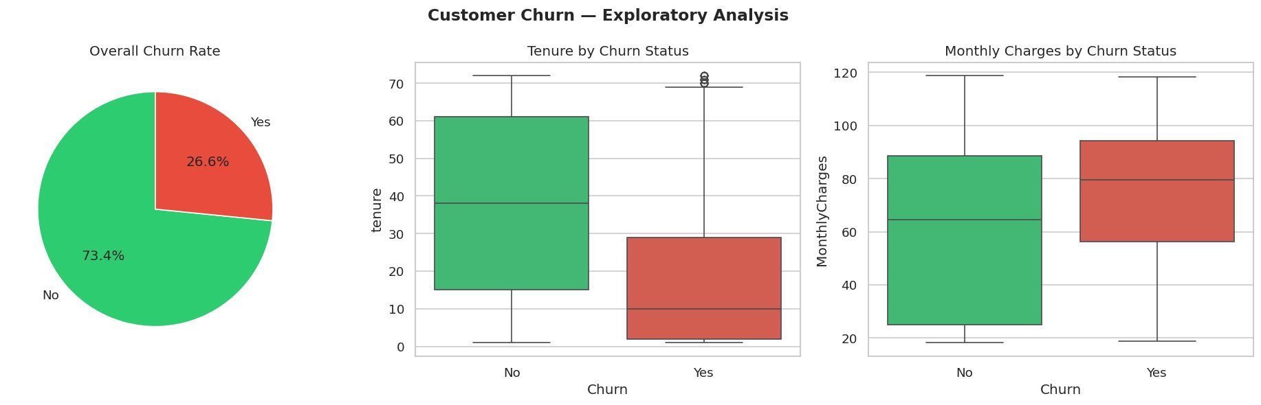
Figure 1 — Overall churn rate (26.6%), tenure by churn status, and monthly charges by churn status
4.2 Churn by Contract Type
The contract type analysis produced the starkest finding in the entire project. Month-to-month customers generate nearly as many churners as retained customers — a ratio completely different for annual and two-year contracts, where churn is a fraction of the retained base.
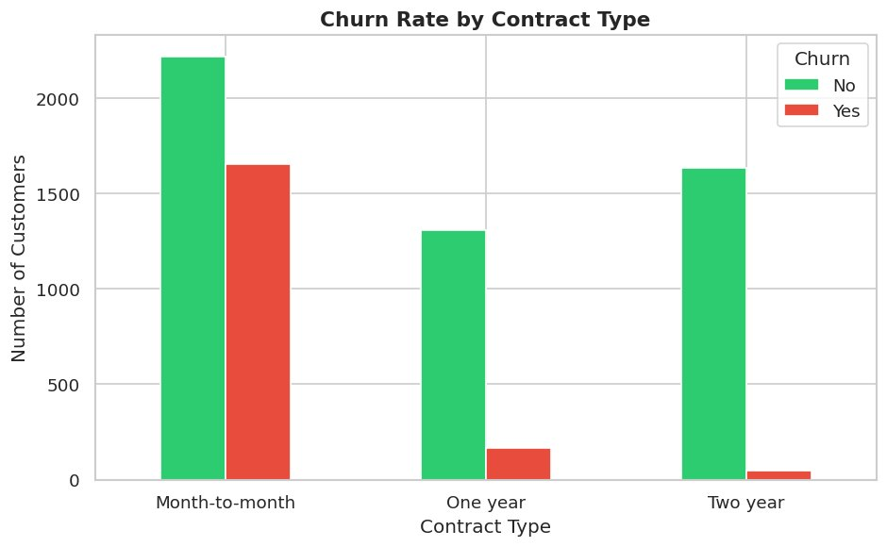
Figure 2 — Churn volume by contract type

Contract Type | Churn Rate | Risk | Interpretation
Month-to-Month | ~43% | HIGH | Most flexible — easiest to cancel
One Year | ~11% | MEDIUM | Some commitment — moderate loyalty
Two Year | ~3% | LOW | Strong commitment — highly retained
5. Machine Learning Models
Two classification models were trained and evaluated to predict whether an individual customer would churn. The dataset was split 80/20 into training and test sets using stratified sampling to preserve the natural class ratio in both subsets.
5.1 ROC Curve — Model Comparison
The ROC curve is the most informative single visualisation for comparing binary classifiers. A curve that hugs the top-left corner is better. The AUC score summarises performance — 1.0 is perfect, 0.5 is random guessing.
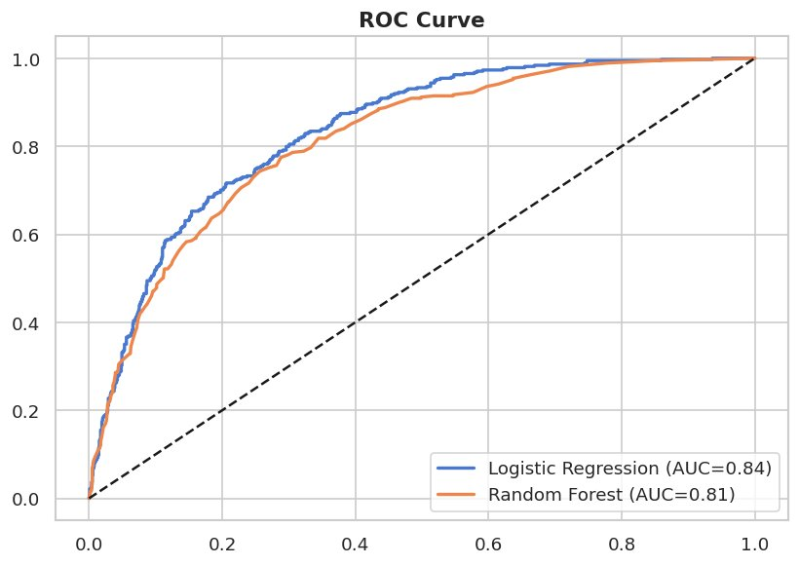
Figure 3 — ROC curves for Logistic Regression (AUC = 0.84) and Random Forest (AUC = 0.81)
5.2 Model Performance Summary

Model | Performance
Logistic Regression | Accuracy ~80%, AUC 0.84 — best overall performance
Random Forest | Accuracy ~79%, AUC 0.81 — best for feature importance
Train/Test Split | 80% training / 20% test, stratified by churn label
Scaling | StandardScaler applied for Logistic Regression
Random Seed | 42 — ensures reproducibility across runs
5.3 Confusion Matrices
The confusion matrices below show how each model classified the test set of 1,409 customers. Correct predictions appear on the diagonal. Logistic Regression correctly identified 215 churners out of 374 (57.5% recall). Random Forest identified 187 out of 374 (50% recall).
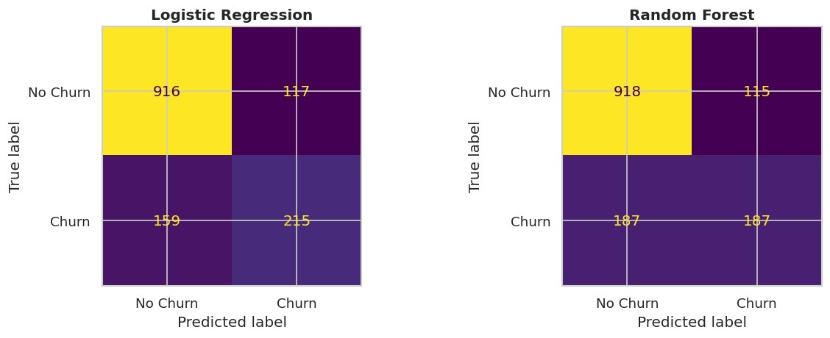
Figure 4 — Confusion matrices for Logistic Regression (left) and Random Forest (right)
6. Feature Importance
One of the most valuable outputs of the Random Forest model is its ability to rank features by predictive importance. This tells us not just whether the model works, but why — which customer attributes are most strongly associated with churn.
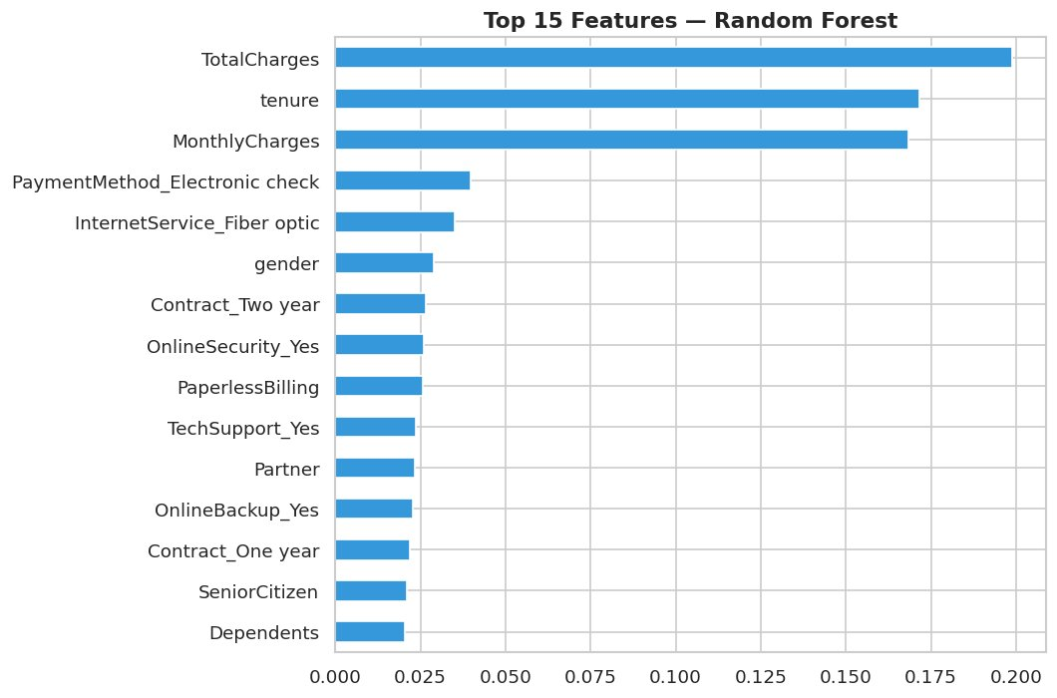
Figure 5 — Top 15 features ranked by importance in the Random Forest model

Feature | Business Interpretation
1. Total Charges | Lifetime revenue — proxy for loyalty depth
2. Tenure | Months with company — strongest retention signal
3. Monthly Charges | Higher bills create price sensitivity and churn risk
4. Electronic Check | Associated with less engaged, higher-risk customers
5. Fibre Optic | Fibre customers churn more — possibly price-related
6. Two-Year Contract | Strong negative predictor — two-year customers stay
7. Online Security / Tech Support | Lacking these services is associated with higher churn
7. Business Recommendations
Data analysis has value only when it leads to action. The following four recommendations are drawn directly from the patterns identified in this analysis and are ordered by estimated business impact.
Recommendation 1 — Convert Month-to-Month Customers
With a churn rate of approximately 43%, month-to-month customers represent the highest-priority intervention target. Two-year customers churn at just 3% — contract length is the single strongest categorical predictor of retention.
- Offer a meaningful discount (10–15%) or free service upgrade to customers who switch to annual contracts
- Run targeted campaigns at the 6-month mark — before the first natural break point where customers reassess
- Position long-term contracts as a benefit rather than a lock-in to reduce resistance
Recommendation 2 — Prioritise the First 18 Months
The tenure analysis shows that churned customers leave early — median tenure for a churned customer is around 10 months. The first year and a half is the most critical window for intervention.
- Assign proactive customer success touchpoints at months 1, 3, 6, 12, and 18
- Use the predictive model to flag new customers who match the high-risk profile and prioritise them for outreach
Recommendation 3 — Bundle Technical Support for New Customers
Technical support appeared in the top 10 predictive features. Customers without it churn more. Including tech support in entry-level plans — or offering it free for the first 6 months — is a low-cost way to improve early experience and reduce churn.
Recommendation 4 — Review Pricing for High-Bill Customers
Churned customers pay an average of approximately £74–80/month, compared to £60–65 for retained customers. Customers paying above £70/month should be considered a price-sensitive segment. Loyalty pricing or value-add bundles for this group could improve retention without broad price reductions.
8. Conclusion
This project demonstrated how a structured data science approach can turn raw customer records into clear, actionable business insight. Starting from a dataset of 7,043 telecom customers, the analysis moved through data cleaning, exploratory analysis, predictive modelling, and business interpretation — covering the complete workflow that organisations rely on to make better decisions.
The most important finding was deceptively simple: the type of contract a customer holds is the most powerful predictor of whether they will stay or leave. Month-to-month customers churn at a rate over 14 times higher than two-year contract holders. Addressing this one factor through targeted incentives and smarter onboarding could have a measurable impact on revenue retention.
The machine learning models — particularly Logistic Regression with an AUC of 0.84 — provide a reliable foundation for a churn prediction system. With further refinement, including threshold optimisation and class balancing techniques such as SMOTE, these models could be deployed in a real production environment to flag at-risk customers before they cancel.

7,043  Records Analysed | 5  Charts Produced | 0.84  Best AUC Score | 4  Recommendations

